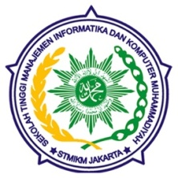**SEKOLAH TINGGI MANAJEMEN INFORMATIKA DAN KOMPUTER**

**MUHAMMADIYAH JAKARTA**

**Jl. Kelapa Dua Wetan No. 17 Ciracas Jakarta Timur**

**021 – 87717489 / 021 – 87717480**

**Email :** [**stmikmuhjkt@gmail.com**](mailto:stmikmuhjkt@gmail.com) **/ websate :** [**www.stmikmj.ac.id**](http://www.stmikmj.ac.id)

**Nama Lengkap : ...............................................................................................................**

**Tanda Tangan**

**Mahasiswa**

**NIM : ...............................................................................................................**

**Jurusan : Teknik Informatika (TI) Sistem Informasi (SI)**

**Matakuliah : ...............................................................................................................**

**Dosen Pengampu : ...............................................................................................................**

**Hari/tanggal : ...............................................................................................................**

|  |
| --- |
|  |
|  |
|  |
|  |
|  |
|  |
|  |
|  |
|  |
|  |
|  |
|  |
|  |
|  |
|  |
|  |
|  |
|  |
|  |
|  |
|  |
|  |
|  |
|  |
|  |
|  |
|  |
|  |
|  |
|  |
|  |